# Scooby Doo Analysis (TidyTuesday)

library(tidyverse)
theme_set(theme_minimal())

# Load the data

library(readr)
scooby <- read_csv( "https://raw.githubusercontent.com/rfordatascience/tidytuesday/master/data/2021/2021-07-13/scoobydoo.csv")
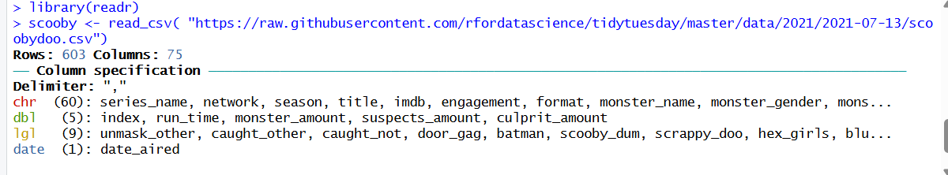
glimpse(scooby)
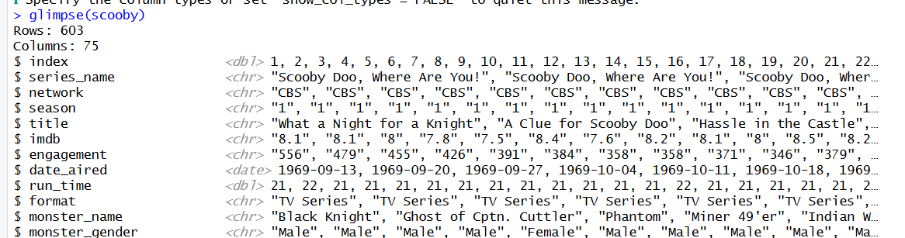

# Prepare the data

scooby_sm <- scooby %>%
select(series_name:format) %>%
mutate(imdb = as.double(imdb))
view(scooby_sm)
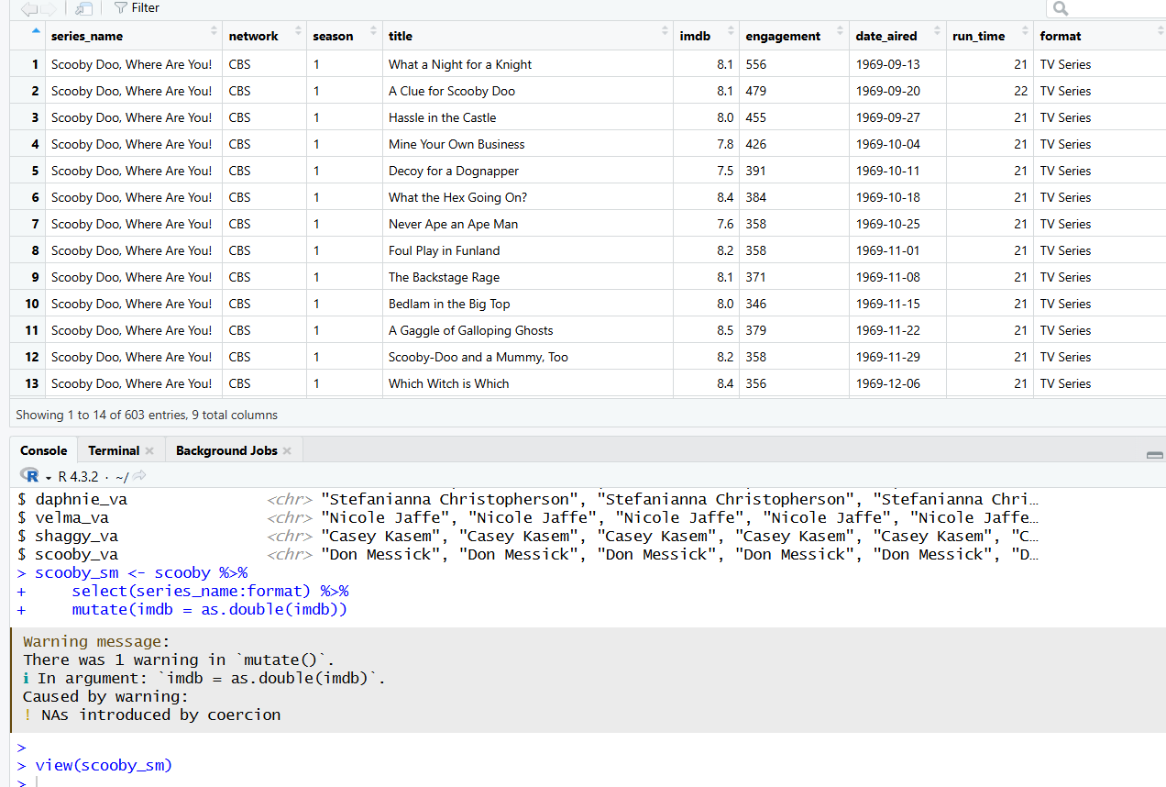

# Preliminary visualization of IMDb ratings over time

ggplot(scooby_sm, aes(x = date_aired, y = imdb, color = format)) + geom_point() + scale_color_brewer(palette = "Dark2")
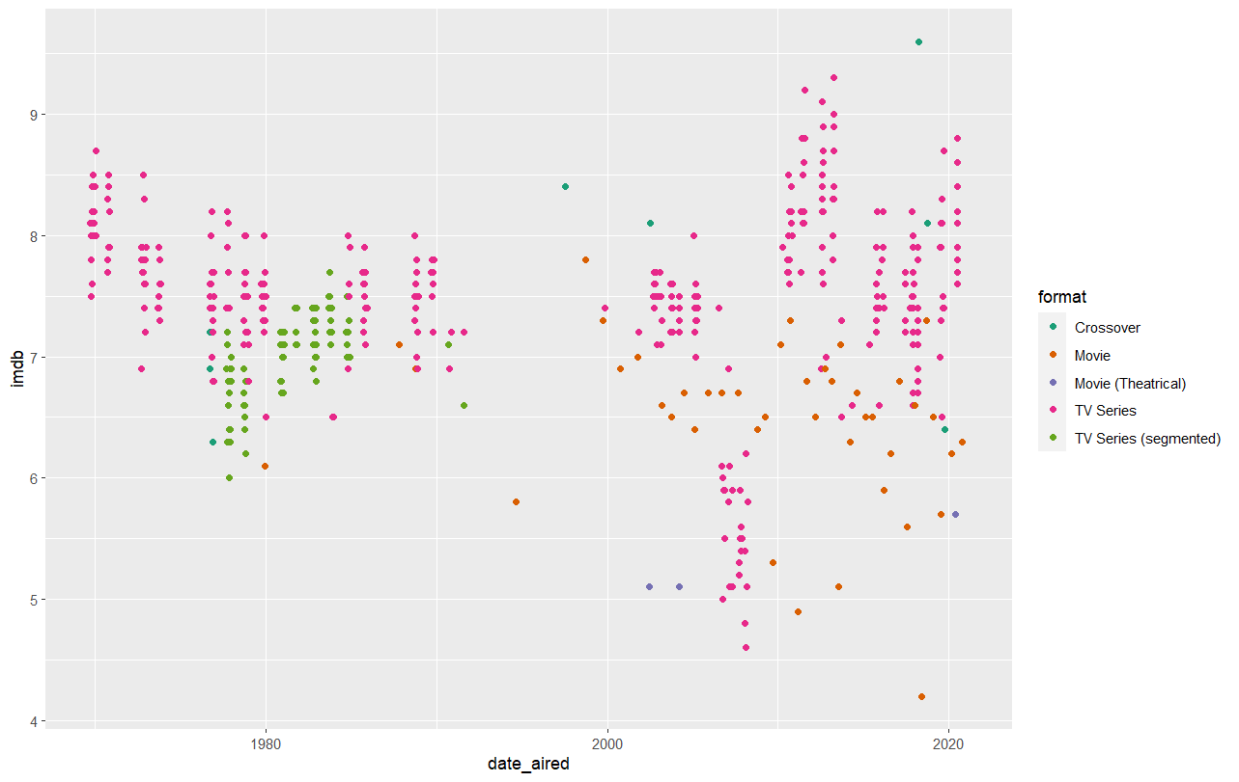
# Exploring format
table(scooby_sm$format)
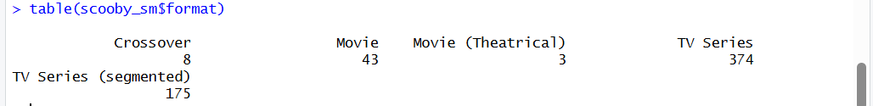
crossover <- filter(scooby_sm, format == "Crossover")
View(crossover)

# Filter all non-TV series episodes
scooby_sm <- scooby_sm %>%
filter(format != "Crossover", format != "Movie", format != "Movie (Theatrical)")

table(scooby_sm$format)
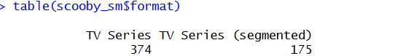
View(scooby_sm)

# Combine segmented episodes
segmented <- scooby_sm %>%
filter(format == "TV Series (segmented)") %>%
group_by(date_aired) %>%
summarize(imdb = mean(imdb),
network = unique(network),
series_name = unique(series_name),
total_runtime = sum(run_time))

View(segmented)
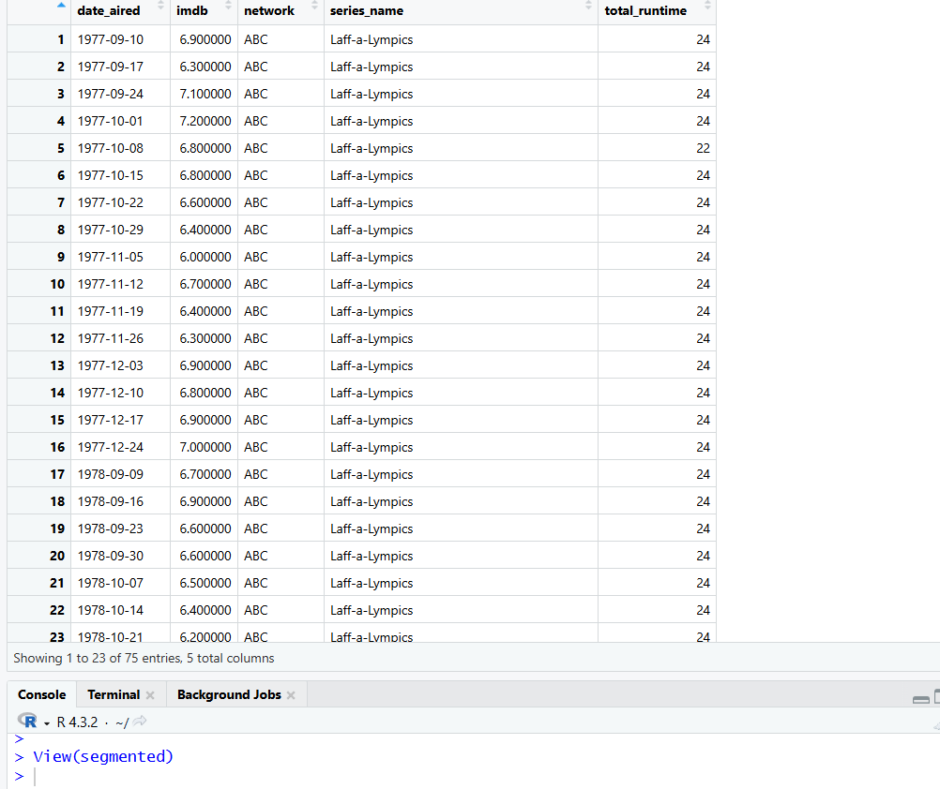

non_seg <- scooby_sm %>%
filter(format != "TV Series (segmented)") %>%
select(date_aired,
imdb,
network,
series_name,
total_runtime = run_time)

scooby_tidied <- rbind(non_seg,
segmented)
View(scooby_tidied)

# Visualization: imdb ratings by network

ggplot(scooby_tidied, aes(x = date_aired, y = imdb, col = network)) + geom_point() + scale_color_brewer(palette = "Dark2")
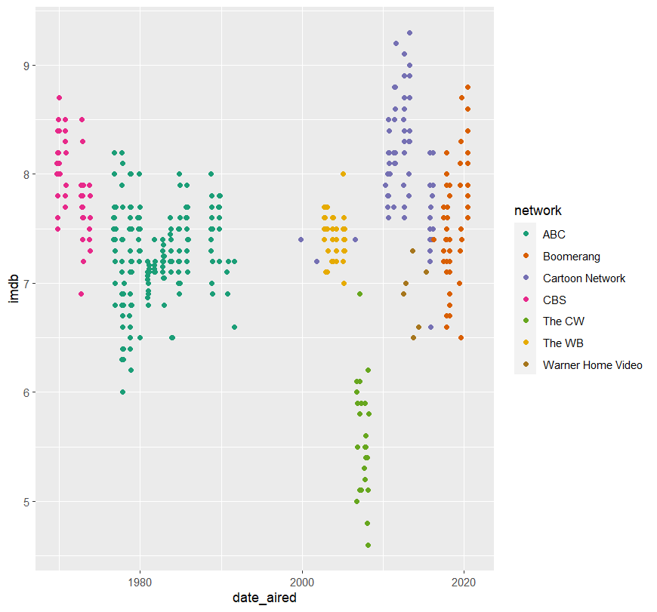

cw <- scooby_tidied %>%
filter(network == "The CW")
View(cw)

# Bar chart: average imdb ratings by network

scooby_tidied %>%
group_by(network) %>%
summarize(mean_imdb = mean(imdb, na.rm = TRUE)) %>%
ggplot(aes(x = fct_reorder(network, -mean_imdb),
y = mean_imdb,
fill = network)) +
geom_col() +
geom_text(aes(label = round(mean_imdb, 1))) +
scale_fill_brewer(palette = "Dark2") +
labs(x = "Network",
y = "Mean imdb rating",
title = "Scooby dooby doo!") +
theme(legend.position = "none",
axis.text.x = element_text(angle = 15))
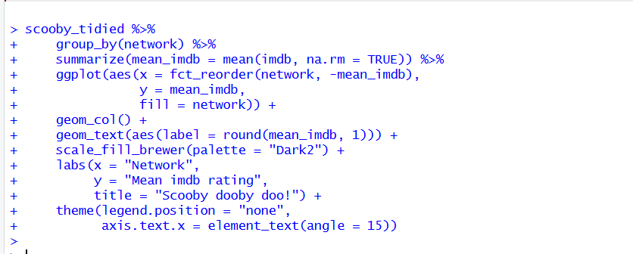

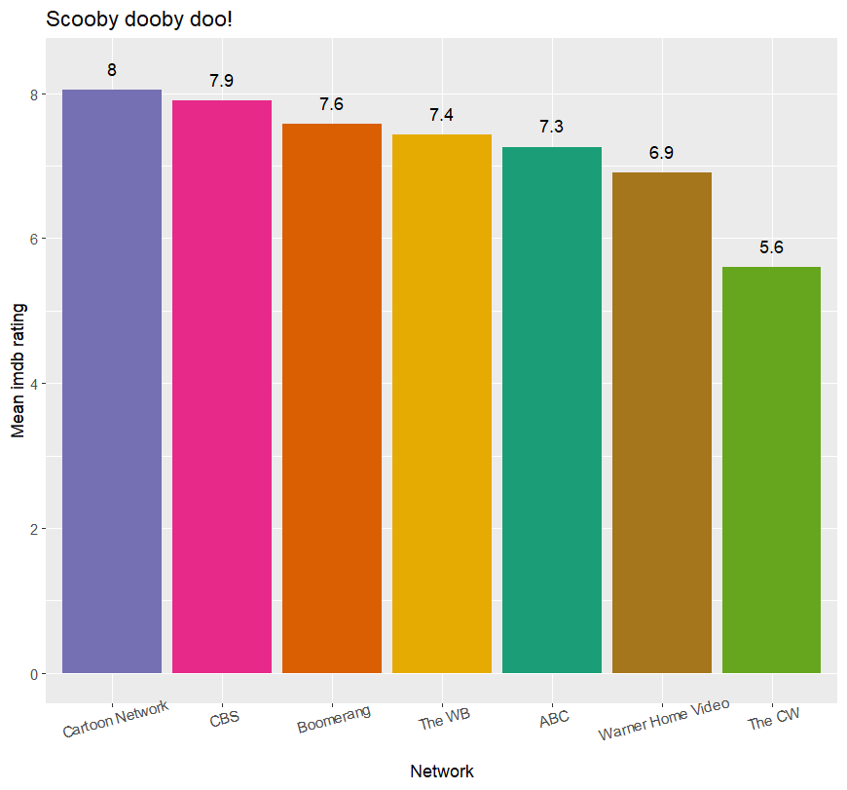# Does network inform imdb? Is The CW really so bad?

model <- aov(imdb ~ network,
data = scooby_tidied)
summary(model)
TukeyHSD(model)

